Aluminium Connectors

Lathe
  - Insert 1 in stock
  - Zero out lathe
    - LENGTH AND DIAMETER
  - Turn the smaller wheel to 240˚, and lathe to approx 2 in (about 20 revolutions on dial)
  - Test fit
    - It will probably not fit if you did it correctly
  - Turn wheel approx 5˚ and lathe again, test fit
  - If it fits great, if it doesn’t turn wheel a little bit and repeat
  - Go to end of material, approx 0.3 in (does not need to be precise), turn on lathe, then carve a small groove out by only turning the small wheel
    - Only do so a couple degrees
  - Go about 0.2 in above groove and cut another one
  - Get metal rasp and remove burrs on the lather
    - Trust it's a lot easier now than after
  - Hollow out the middle using the drill on the lather
    - Use the bit that’s approx 0.39 in
    - Use the cinnamon gunk (not actual cinnamon just smells like it) here it makes the lather a lot happier
  - Carefully cut the lathed portion off leaving the corresponding amount of stock for application
    - 1.300 in for vertical members
    - 2.300 in for one ended horizontal members
    - 4.400 in for double ended horizontal members
  - For double ended members, repeat process on other side
  - WHEN REMOVING BE CAREFUL METAL IS HOT
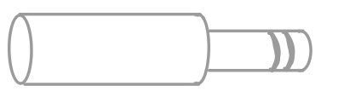
  - The connector should look something like this:
OR
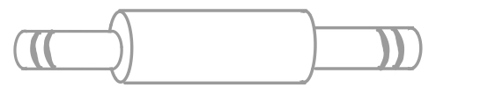

Milling
  - WEAR LONG SLEEVES, HOOD, AND COVER COLLARBONE
    - Just trust it's not pleasant when hot and sharp metal pieces are flying at your face
  - Set up connector in square holder
    - Will need the 0.75 size round holder that goes into the square block
    - Lathed connector will go in end opposite to the thing you screw on the bottom of the block
    - Will need to tighten until you can't tighten anymore with the wrench
  - If necessary, clean machine so no shavings are where the block will go
    - Use the tiny brush try to prevent flying metal pieces
  - Place block holding connector in the machine
    - make sure block is flush to the side of the clamps using the small metal square
    - Run your finger across the seam to verify that it is flush
    - Tighten
  - If necessary, put the right bit into the machine
    - Ask J to show you how
    - Need to hold the machine’s brake and turn the bolt on top using the wrench
      - I can’t reach so I usually either find Zucker’s stool or ask J
  - If necessary, raise the bed of the machine by turning the giant chrome removable crank until the connector is just below the drill bit
    - It's the left crank on the bottom of the bed
    - Give yourself a couple inches of bail room
  - If necessary, change the speed of the machine using the dial on the front
    - Ask J which speed to use
    - Want the machine on high
    - Want something around 1200
  - Zero the machine (Z-axis)
    - Ask J to show you how
    - Hit the DRO button to get to the right menu
    - Crack various wheels until connector is under the drill bit
    - Put tiny piece of paper on the top of the connector
    - Crank the giant lever on the right side
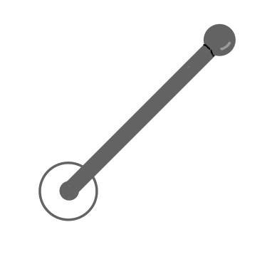
      - It looks like this:

      - (refrain from saying “Wrong lever Kronk”)
    - Crank lever until you can still pull the piece of paper out but there is a little bit of resistance
    - Turn the smaller black lever so that it locks
      - It looks like this:
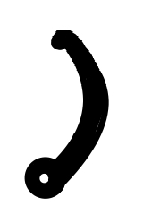
    - On the screen hit “Z” and then “abs zero”
  - Use the wheels to move the connector from under the drill
  - Rotate the giant lever out and crank until the screen says -0.365 in
  - Zero the machine (X-axis)
    - Make sure the drill is a bit away from the connector, turn the machine on
    - Move the connector so that the drill takes the smallest amount of material off
    - Zero the screen (same as on Z-axis)
  - Take material off in small X-axis increments by cranking the Y-axis wheel so that the bit moves back and forth
    - J suggests going in 0.02 in increments, but I suggest somewhere around 0.04. You just have to make sure everything is tight so that the connector doesn’t rotate when you mill it flat
  - Take the correct amount of material off
    - Amount will vary depending on measurements of the individual connector
    - Leave 0.3 in of a rim for vertical and one sided horizontal connectors
    - Leave 0.2 in of a rim on each side for a double sided horizontal connector
  - Repeat on the other side
    - Make sure connector and block is going on clean, level surface
    - Make sure connector and block is flush with the clamp
    - Re-zero X-axis, you do not need to re-zero Y-axis
  - Use a metal rasp to remove the burrs
  - The milled connector will look something like this:
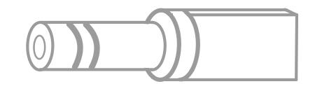
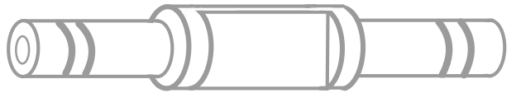
OR

Drilling
  - Use mill machine
  - Change drill bit from milling to drilling
    - Will want something that makes a pilot hole and then a ⅜ in drill bit
  - Mark the correct spot on the flat part of the connector
  - For one ended pieces
    - Put the flat part of connector on top of the metal pieces in the clamp
      - They look like this:
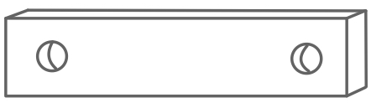
    - Tighten clamp
    - Drill pilot hole, change drill bit, drill actual hole
  - For double ended pieces
    - Put the flat part of connector on smaller square aluminium tubes in the clamp
      - Use as many scrap square tubes as needed to make top clamp-able and flush-ish (try your best)
    - Use same process as one ended pieces
  - Your final product should look something like this:
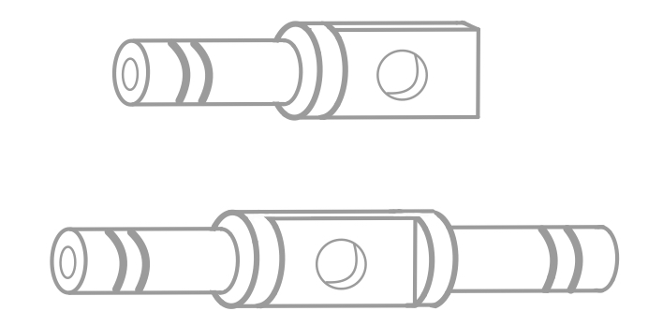

Carbon Fibre

Cutting
  - Wrap in blue tape before cutting, prevents splintering
  - If you cut the piece slightly too long you can sand it down to size

3D Printed Pieces
- See Directions for Markforged
- Files are located in folder
- To remove supports, twist then pull

